1. **Display inbound students taking module from Faculty of Science**

SELECT INSTU_ID, INSTU_NAME

FROM INBOUND_STUDENT

WHERE INSTU_ID IN

(SELECT INSTU_ID

FROM ENROLL INNER JOIN MODULE

ON ENROLL.MODULE_CODE = MODULE.MODULE_CODE

WHERE FAC_CODE = ‘FS’)

ORDER BY INSTU_ID;

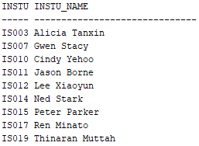

1. **Display inbound student paying less than RM400 for administration fee via financial aid**

SELECT INSTU_ID, INSTU_NAME, PAYMENT_METHOD, ADMIN_FEE

FROM INBOUND_STUDENT

INNER JOIN PAYMENT

ON INBOUND_STUDENT.PAYMENT_ID = PAYMENT.PAYMENT_ID

INNER JOIN FEE

ON PAYMENT.FEE_CODE = FEE.FEE_CODE

WHERE PAYMENT_METHOD = ‘Financial Aid’

AND ADMIN_FEE <= 400;

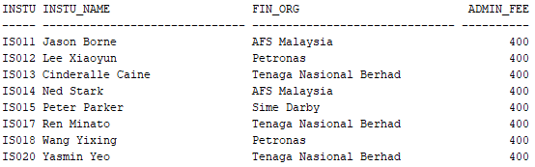

1. **Display the coordinator’s details which handle the outbound student.**  
     
   SELECT COOR_ID, COORD_NAME, OUTSTU_ID, OUTSTU_NAME, OUTSTU_GENDER, OUTPROG_TYPE, OUTPROG_DURATION  
   FROM  
   UNI_COORD  
   INNER JOIN  
   OUTBOUND_PROGRAM  
   ON  
   UNI_COORD.UNI_ID = OUTBOUND_PROGRAM.UNI_ID  
   INNER JOIN  
   OUTBOUND_STUDENT  
   ON  
   OUTBOUND_PROGRAM.OUTPROG_ID = OUTBOUND_STUDENT.OUTPROG_ID  
   WHERE  
   COORD_NAME = ‘Allen’  
   AND  
   OUTPROG_TYPE = ‘short_term’  
   ORDER BY  
   COORD_NAME;

|  |
| --- |

1. **Update the amount of financial aid for specific financial organization.**

UPDATE UNIVERSITY  
SET  
UNI_NAME = ‘Tsinghua University’, UNI_IS_PARTNER = ‘Yes’, UNI_AGREEMENT = ‘MoA’  
WHERE  
UNI_ID = ‘U006’;

Before execute:

|  |
| --- |

After executed:

|  |
| --- |

1. Display inbound students information and program based on each financial aid.

SELECT F.FIN_ORG, I.instu_id, i.instu_name, P.INPROG_TYPE FROM

financial_aid F

INNER JOIN inbound_student I

ON F.FIN_ORG = I.FIN_ORG

INNER JOIN Inbound_program P

ON I.INPROG_ID = p.inprog_id

WHERE I.FIN_ORG IS NOT NULL

ORDER BY f.fin_org, i.instu_id;

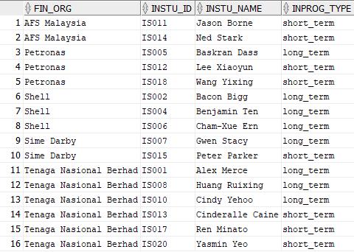

1. Update staff information (email and phone number)

UPDATE STAFF

SET staff_email = 'ken888@gmail.com', staff_contact_number = '012-3456789'

where

staff_id = 'S009';

Before execution:

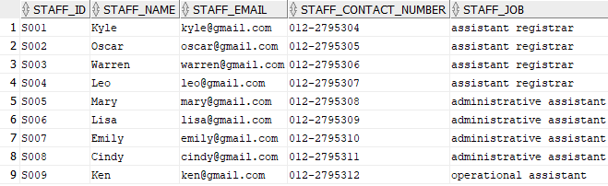

After execution:

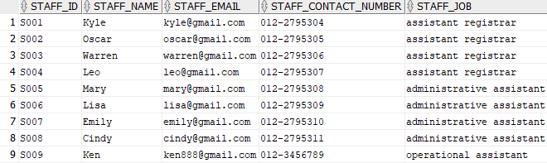

1. Display the student id and student name who get A in Basic Accounting.

SELECT INSTU_ID,INSTU_NAME

FROM INBOUND_STUDENT

WHERE INSTU_ID IN

(SELECT INSTU_ID

FROM ENROLL

WHERE MODULE_CODE = 'FB001' AND ENROLL_GRADE = 'A')

ORDER BY INSTU_ID;

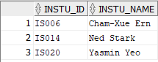

1. Insert new outbound program into OUTBOUND_PROGRAM table.

INSERT INTO OUTBOUND_PROGRAM (OUTPROG_ID, OUTPROG_TYPE, OUTPROG_DURATION, OUTPROG_STARTDATE, UNI_ID)

VALUES ('OP031', 'short term', 6, '1/9/2021', 'U015');

Before execution:

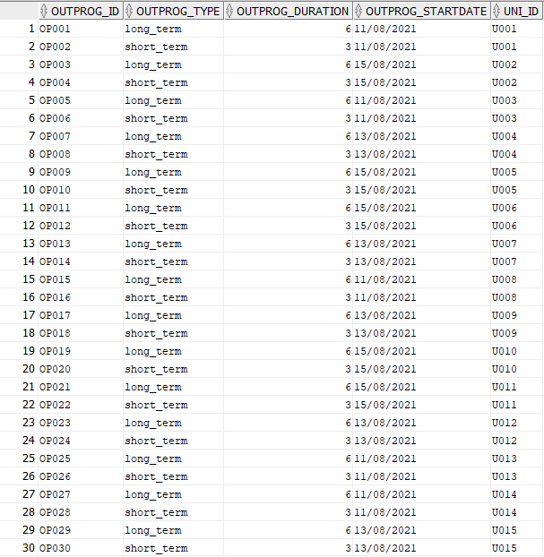

After execution:

